**INTERACTIVE DATA VISUALIZATION**

**ASSIGNMENT -2

MODULE: DATA VISUALIZATION

MSc Data Analytics

DUBLIN BUSINESS SCHOOL

**AUTHORS / TEAM MEMBERS / Student Names: ** ------------------------------------------------------------------------------------------

JULIANA FERNANDES - 10503664

RUSHAB S.L. GOWDA - 10504936

KARTHEEK PRASANNA - 10394030

**TOOLS FOR VISUALIZATION: R STUDIO, GOOGLE VISUALISATION, SHINY APP**

This database is about the heart diseases and various factors involved. As the leading cause of death in the world, heart disease, according to WHO, accounts for 3.8 million and 3.4 million deaths in males and females, respectively.

The symptoms and incidence of heart disease differ from one person to another. However, they commonly include chest pain, jaw pain, neck pain, back pain, [stomach disorders](https://www.omicsonline.org/hepatology-gastrointestinal-disorders.php); arms and shoulders pains and shortness of breath. Different heart problems induce different heart diseases including coronary artery disease, heart failure and stroke.

**Contribution:** Each team member has contributes and fulfilled the following tasks.

1. Environment: set setup (installation of packages / libraries)

2. Data Preprocessing (Data cleaning, Shaping)

3. Framing the Business questions

4. Analyzing the code and executing it

5. Forming different insights for the dataset

6. Deploying the results in shiny.

**JULIANA FERNANDES - 10503664-----------------------------------------------------------**

1. Environment: set setup (installation of packages / libraries)

2. Data Preprocessing (Data cleaning, Shaping)

**RUSHAB S.L. GOWDA – 10504936--------------------------------------**

3. Framing the Business questions

4. Analyzing the code and executing it

**KARTHEEK PRASANNA - 10394030 -------------------------------------------**

5. Forming different insights for the dataset

6. Deploying the results in shiny.

# **BUSINESS QUESTIONS**

1.) What is the average cholesterol level of patients depending upon the gender?

2.) What is the maximum heart rate achieved according to the chest pain type?

3.) What is the slope of the ST depression in male and female?

* The whole process of framing business questions, analyzing, deploying took around 1 week for us. The code execution and debugging consumed more time as it was more challenging to create interactive graphs.
* We chose the particular dataset and came to a conclusion because of the critical issue we are facing nowadays i.e. heart disease, so we wanted to know what are the factors affecting it and how we can overcome these issues.
* We chose R studio for the code execution and for interface we chose shiny app as it is a powerful and simple web based library. Along with these we also did a simple visualization using google visualization tool to get to know we can work in any environment and provide insights.
* After the successful execution we got the following results as shown in the screenshots below which is also explained in the report.

**FIGURES: AVERAGE CHOLESTORAL LEVEL vs NUMBER OF PATIENTS**

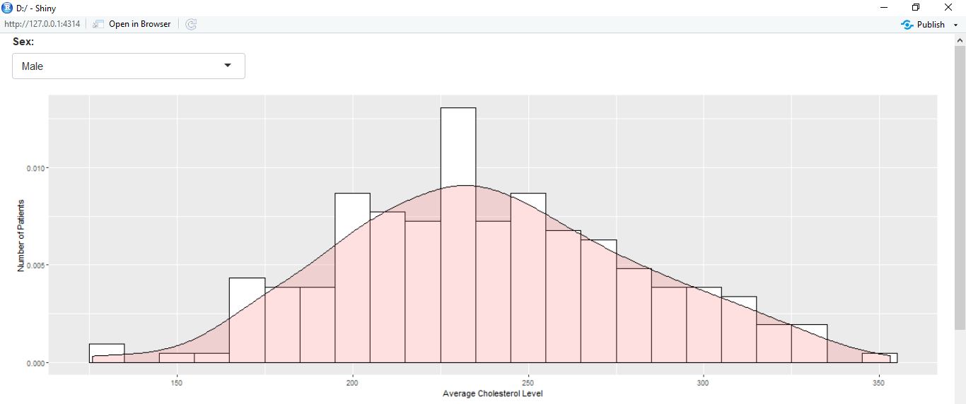

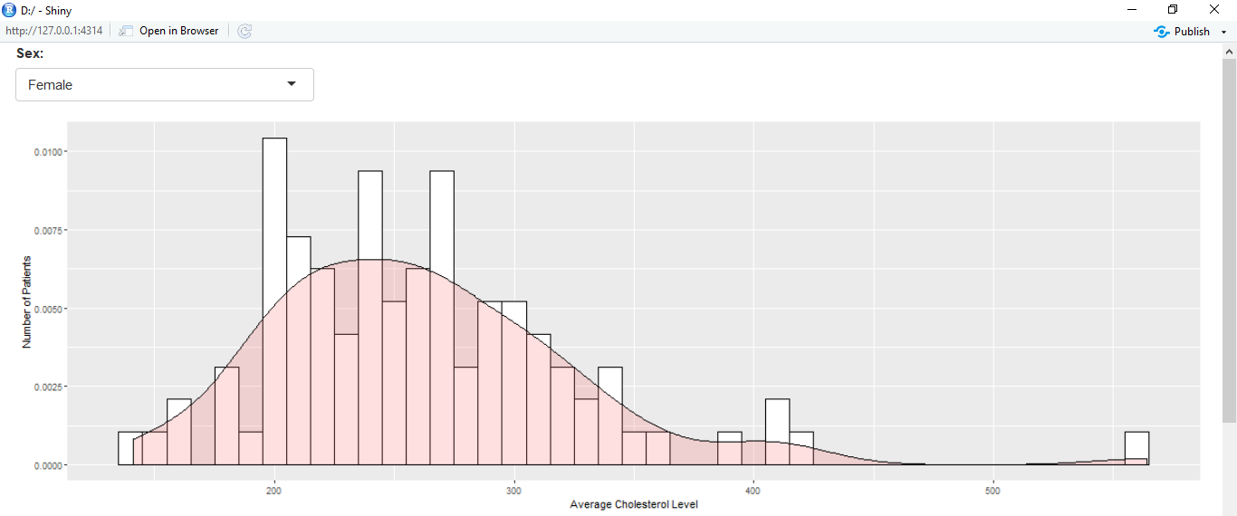

**FIGURES OF CHEST PAIN ACCORDING TO TYPE 0,1,2,3.**

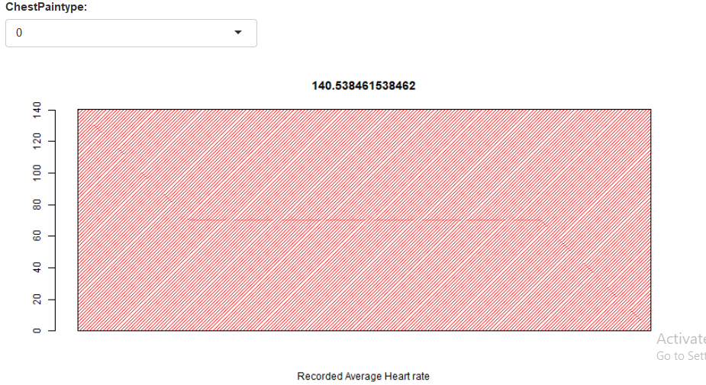

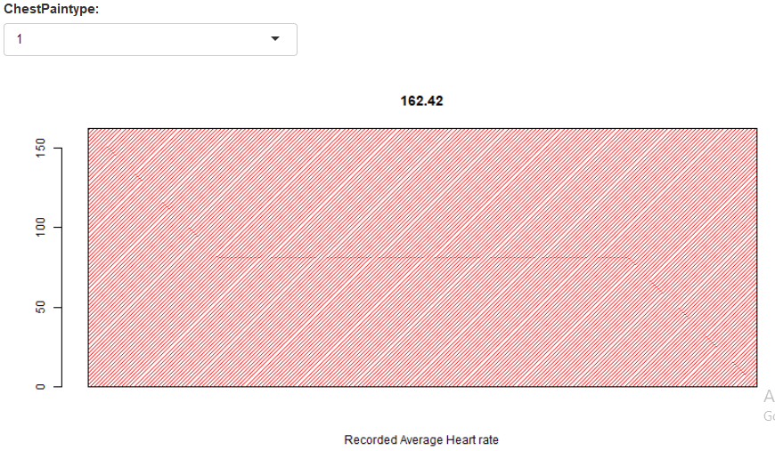

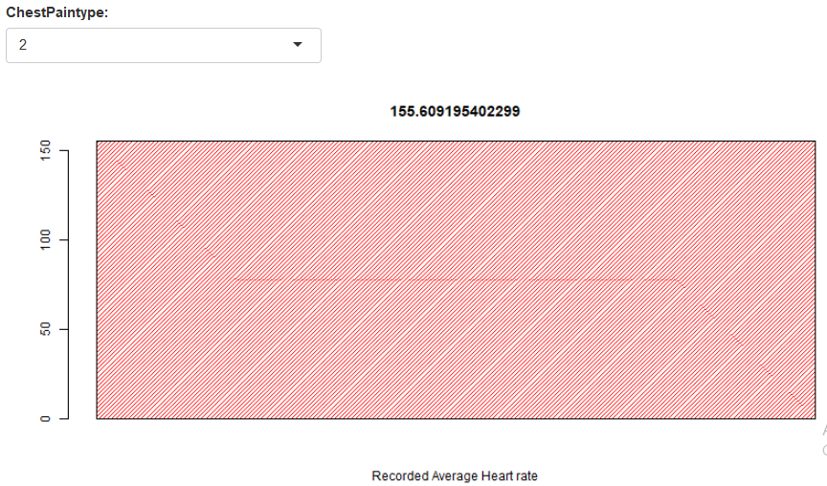

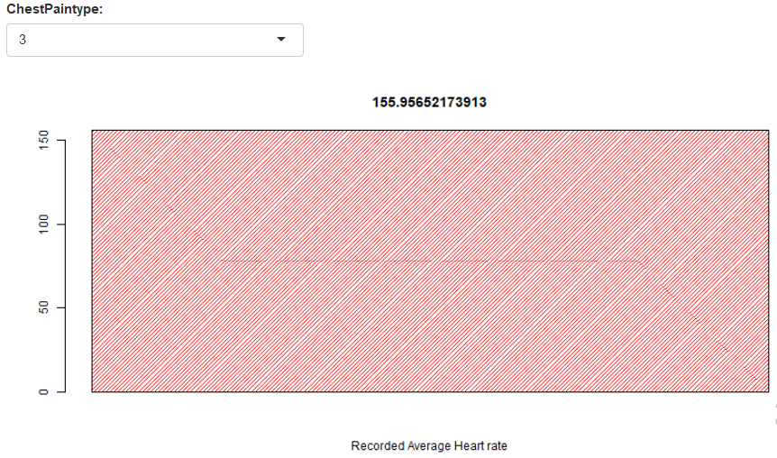

**FIGURES : ST DEPRESSION DENSITY IN MALE AND FEMALE**

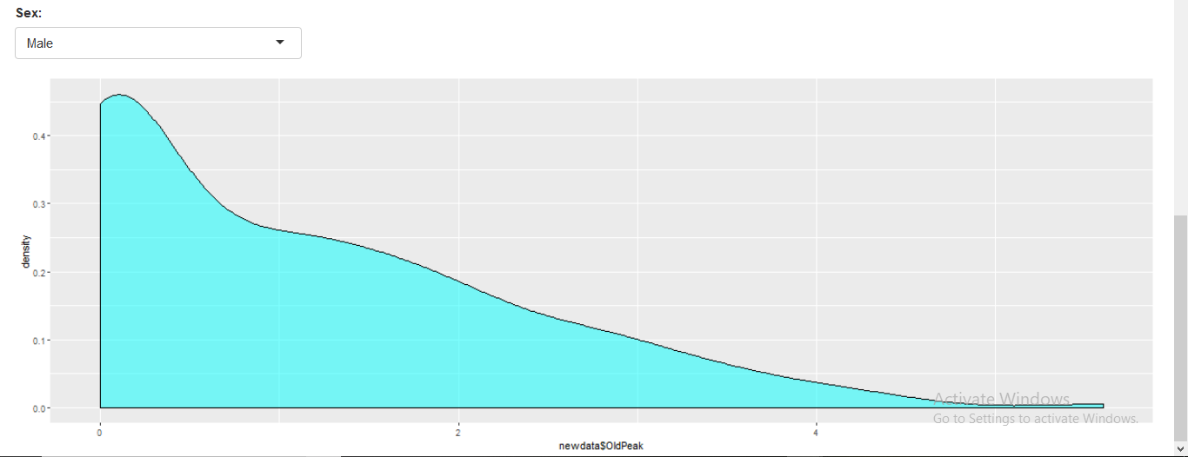

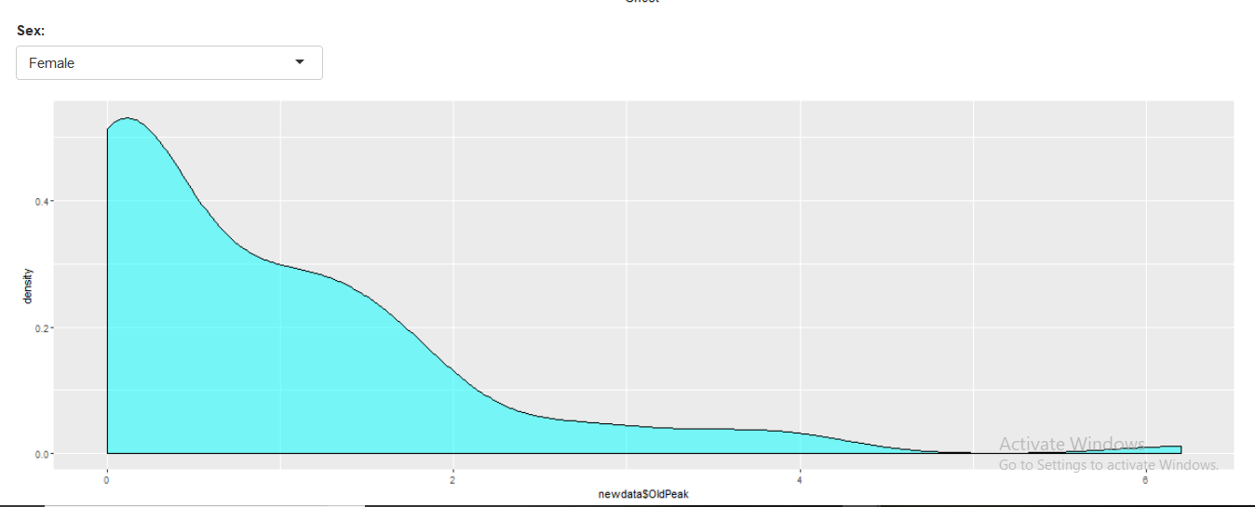

**FIGURES : CHOLESTROL VS RESTING BPS**



